Control network bandwidth
After you use Site Recovery Deployment Planner to calculate the bandwidth you need for replication (initial replication and then the delta), you have a couple of options for controlling the amount of bandwidth that's used for replication:
- Throttle bandwidth: VMware traffic that replicates to Azure goes through a specific process server. You can throttle bandwidth on the machines that are running as process servers.
- Influence bandwidth: You can influence the bandwidth that's used for replication by using a couple of registry keys:
  - The HKEY_LOCAL_MACHINE\SOFTWARE\Microsoft\Windows Azure Backup\Replication\UploadThreadsPerVM registry value specifies the number of threads that are used for data transfer (initial or delta replication) of a disk. A higher value increases the network bandwidth that's used for replication.
  - The HKEY_LOCAL_MACHINE\SOFTWARE\Microsoft\Windows Azure Backup\Replication\DownloadThreadsPerVM registry value specifies the number of threads that are used for data transfer during failback.

Throttle bandwidth
- Open the Azure Backup MMC snap-in on the ASR Config/Process server or Hyper-V host. By default, a shortcut for Backup is available on the desktop, in the start menu, or in the following folder: C:\Program Files\Microsoft Azure Recovery Services Agent\bin.
- In the snap-in, select Change Properties.
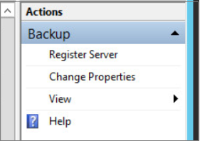
- On the Throttling tab, select Enable internet bandwidth usage throttling for backup operations. Set the limits for work and non-work hours. Valid ranges are from 512 Kbps to 1,023 Mbps.
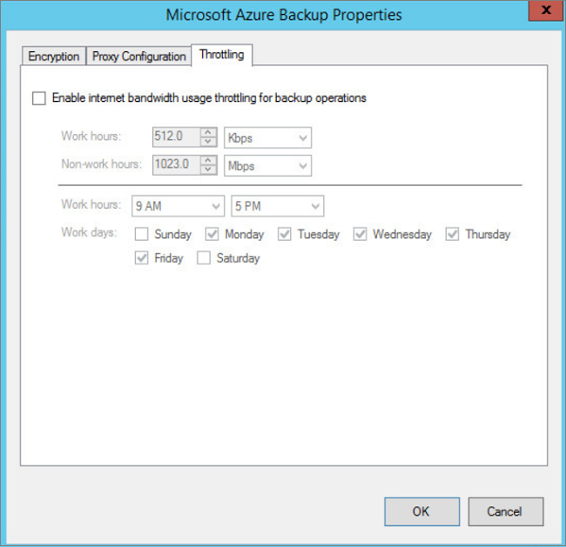
You can also use the Set-OBMachineSetting cmdlet to set throttling. Here's an example:
Copy
$mon = [System.DayOfWeek]::Monday
$tue = [System.DayOfWeek]::Tuesday
Set-OBMachineSetting -WorkDay $mon, $tue -StartWorkHour "9:00:00" -EndWorkHour "18:00:00" -WorkHourBandwidth (512*1024) -NonWorkHourBandwidth (2048*1024)
Set-OBMachineSetting -NoThrottle indicates that no throttling is required.

Alter the network bandwidth for a VM
- In the VM's registry, go to HKEY_LOCAL_MACHINE\SOFTWARE\Microsoft\Windows Azure Backup\Replication.
  - To alter the bandwidth traffic on a replicating disk, modify the value of UploadThreadsPerVM. Create the key if it doesn't exist.
  - To alter the bandwidth for failback traffic from Azure, modify the value of DownloadThreadsPerVM.
- The default value for each key is 4. In an “overprovisioned” network, these registry keys should be changed from the default values. The maximum value you can use is 32. Monitor traffic to optimize the value.

